**COVID-19 impact on education**

Erdem ÖZTÜRK

Ankara Yıldırım Beyazıt University

Prof. Dr. Halil Kemal Ilter

June, 2021

**Abstract**

The purpose of this research is to examine the negative effects of the coronavirus epidemic on education. It aims to reveal the impact of COVID-19 on education by examining the situations in the countries during the academic year.

***Keywords: education, visualization, Coronavirus,***

**Introduction**

The COVID-19 virus emerged on December 1, 2019 in Wuhan, the capital of China's Hubei region. Shortly after its start, this pandemic, which negatively affected us in all areas of our lives, took us under its influence for a long time. The most prominent of these negative effects is the curfew imposed by the countries. This situation affected the business life of people, the education life of students, that is, almost the whole life. Because of this situation, education life has been really difficult for students. In fact, there were educational periods not only for students but also for lecturers. Lack of adequate training makes exams difficult. Students go to school next year with insufficient knowledge. That's why education and training has really been adversely affected during the COVID-19 period.

**Method**

A dataset containing 20581 data was used in this study. A due diligence was made with the data starting on 17.02.2020 and covering the last day until 30.06.2021. Then, data quality was made over five countries, namely Turkey, Germany, China and Argentina and Portugal. The new tables made up of data quality were used for data visualization and graph making.

In the tables created, the education-training periods were examined in 4 cases. The situations are:

***Closed due to COVID-19:*** Government-mandated closures of educational institutions affecting most or all of the student population enrolled from pre-primary through to upper secondary levels [ISCED levels 0 to 3]. In most cases, various distance learning strategies are deployed to ensure educational continuity.

***Academic break:*** Most schools across the country are on scheduled academic breaks for periods of at least four weeks. All study during this period is suspended.

***Fully open:*** For the majority of schools, classes are being held exclusively in person, noting that measures to ensure safety and hygiene in schools vary considerably from context to context and/or by level of education.

***Partially open:*** Governments have mandated (a) partial reopening in certain areas, and/or (b) a phased re-opening by grade level or age and/or (c) the use of a hybrid approach combining in-person and distance learning. It also includes the countries where national governments have deferred decisions on re-opening to other administrative units (e.g. region, municipality or individual schools), and where a variety of re-opening modalities are being used.

**Results**

***Education situation in Portugal during Covid-19***

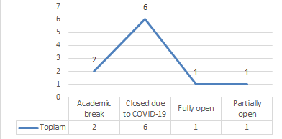

Our table shows the situations during the academic year in Portugal during the Covid-19 period. Portugal, which took an academic break for 2 times, shares the first place with Turkey among the countries that closed their schools mostly due to Covid among the countries examined with 6 times. As it can be understood from here, the students had a difficult academic year. The schools, which were fully open once and partially opened once, were adversely affected during the Covid-19 period.

***Education-teaching situations in Turkey in the Covid-19 pandemic***

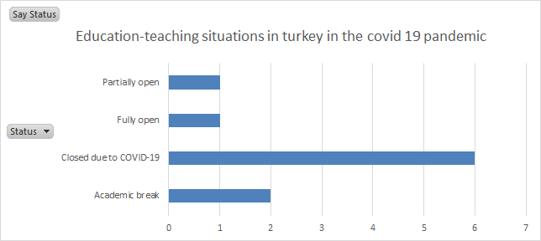

Our table shows the situations in the academic year in Turkey during the Covid-19 period. Turkey, which took an academic break for 2 times, shares the first place with Portugal among the countries that have closed their schools mostly due to covid among the countries examined with 6 times. As it can be understood from here, the students had a difficult academic year. The schools, which were fully open once and partially opened once, were adversely affected during the Covid-19 period. In the current period, schools continue to be partially open, but it cannot be said that it has been a productive period.

***The state of education in Germany during the Covid-19 period***

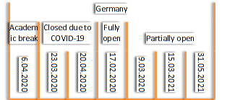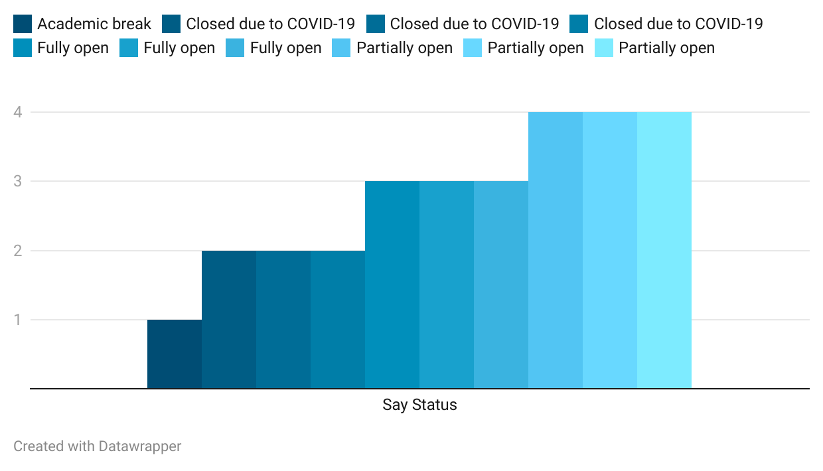

Our table shows the situations during the academic year in Germany during the Covid-19 period. Germany, which took an academic break once, is in the last place among the countries that closed its schools due to Covid among the countries that were examined twice. As it can be understood from here, students had a more comfortable academic year compared to other countries. The schools, which were fully open once and partially opened 3 times, were affected much less negatively during the Covid-19 period compared to other countries. During the current period, schools continue to be partially open.

***The state of education in China during the Covid-19 era***

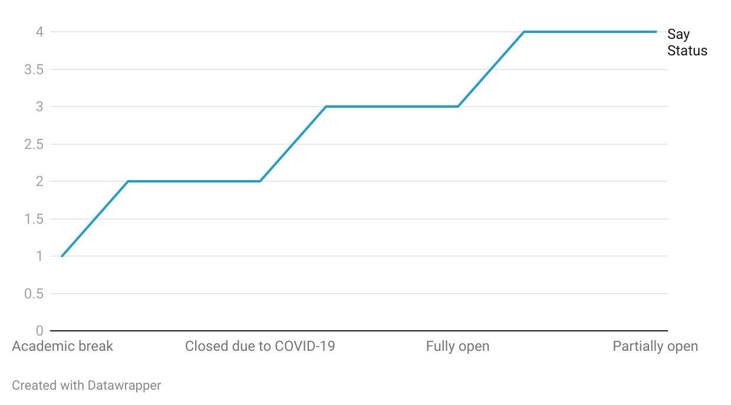

Our table shows the situations in the academic year in China during the Covid-19 period. Germany, which took an academic break once, is in the last place among the countries that closed its schools due to Covid among the countries that were examined for 3 times. As it can be understood from here, students had a more comfortable academic year compared to other countries. Schools that were fully open 3 times and partially opened 3 times were affected much less negatively during the Covid-19 period compared to other countries. During the current period, schools continue to be partially open.

***The state of education in China during the Covid-19 era***

***Covid onset education table***

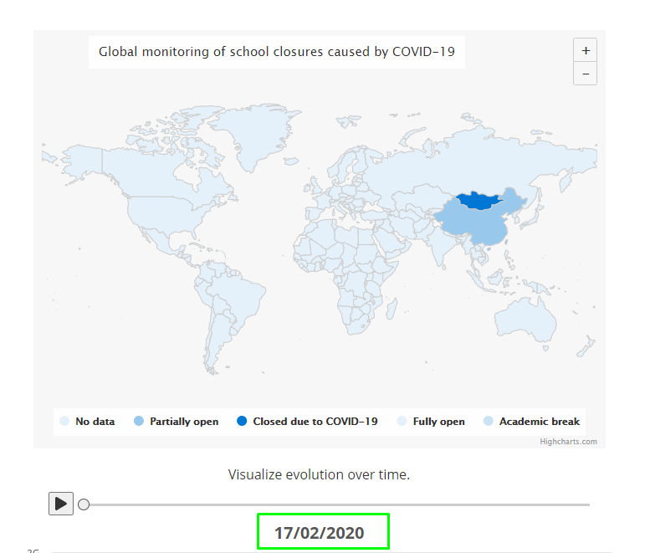

***Post-Covid 3rd month education teaching table***

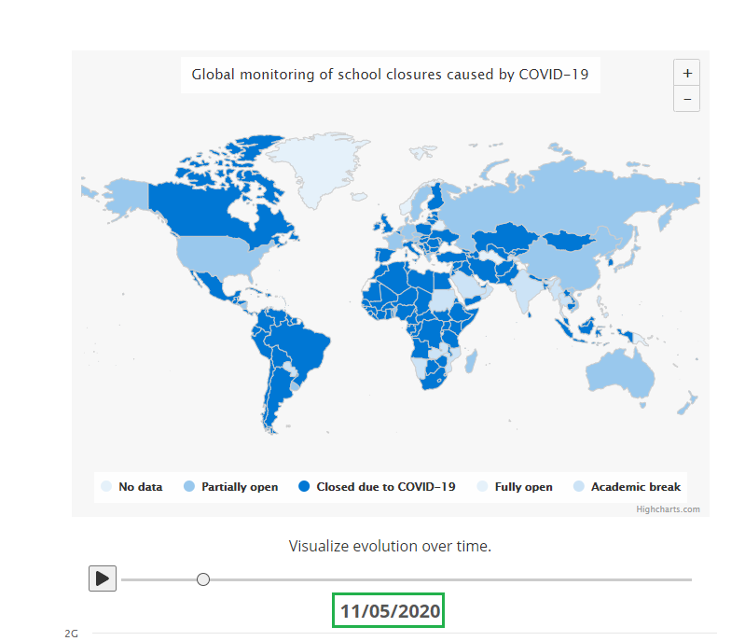

***6th month education and training table after Covid start***

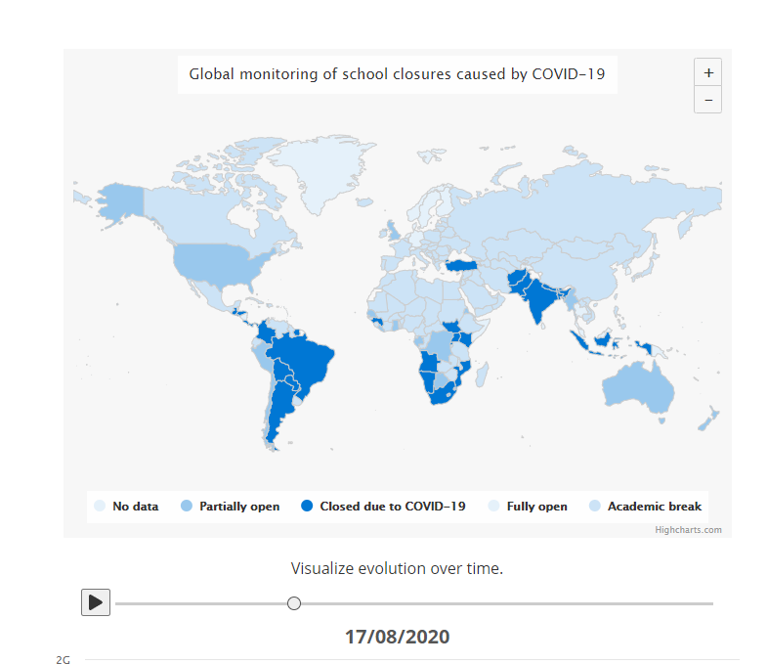

***The impact of covid 19 on education today***

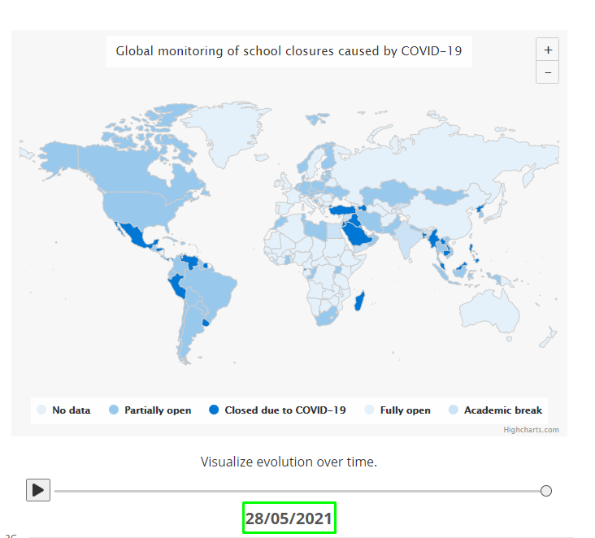

**Conclusion**

The coronavirus epidemic has adversely affected countries and people in many different areas. Education is just one of these areas. The measures taken, partially open, closure due to Covid, completely open, have affected the education very negatively. However, this was not at the same level for all countries. According to the development level of the countries, education was less affected by this pandemic.

**References**

<https://data.world/liz-friedman/covid-19-impact-on-education>

<https://en.unesco.org/covid19/educationresponse>

<https://en.unesco.org/sites/default/files/unesco-map-covid-19-caused-school-closures-and-reopening-methodological-note-en.pdf>

<https://data.world/resources/coronavirus/>